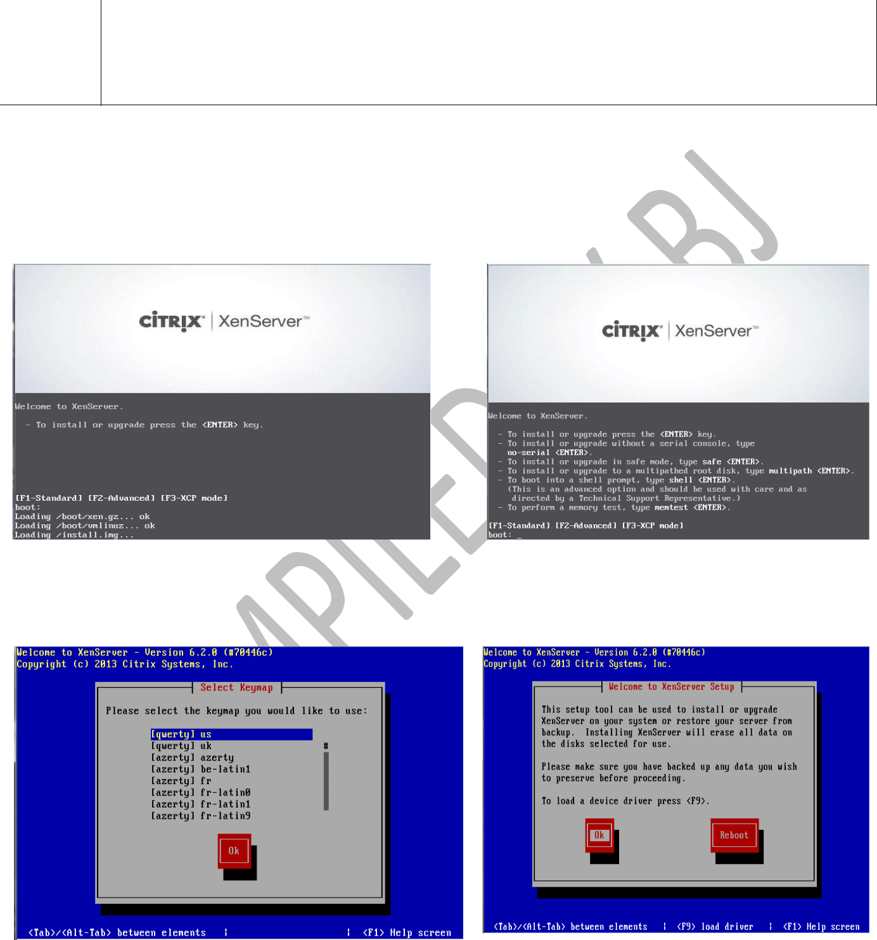

**Step 1: Install Xen Server**

**Step i-: Insert Bootable Xen Server CD into CDROM and Make first boot device as a CDROM from BIOS**

**Step ii-: press F2 to see the advanced options, otherwise press Enter to start installation**

**Step iii -: Select Keyboard Layout** **Step iv -:Press Enter to load Device Drivers**

**Step v -:Press Enter to Accept End user license Agreement** **Step vi -:Select Appropriate disk on which you want**

|  |  |
| --- | --- |
|  | **to install Xen server** |
|  |  |
| CLOUD COMPUTING LAB MANUAL COMPILED BY | PROF. BHUSHAN JADHAV CONTACT -:9702868662 |
|  |  |

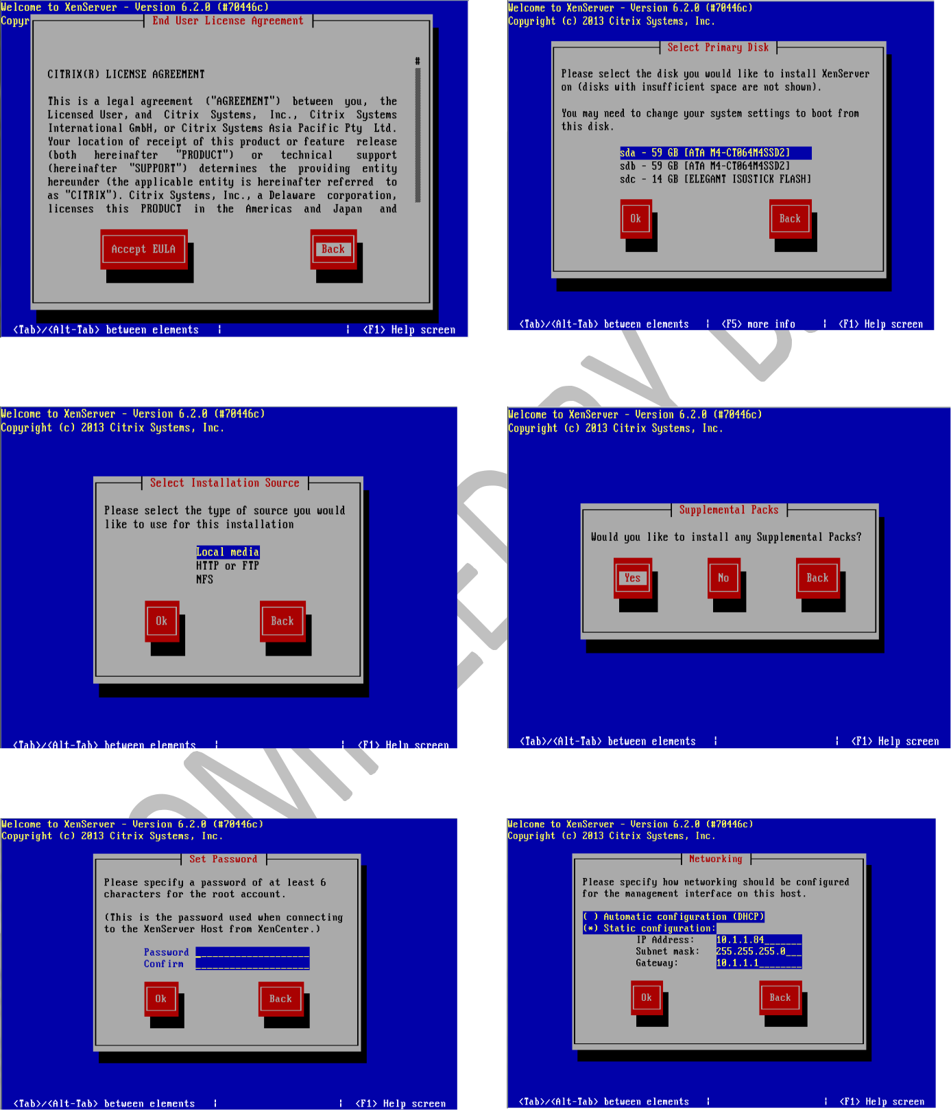

**Step vii -:Select Appropriate installation Media** **Step viii -:Select Additional Packages for installation**

**Step ix-: Specify Root password** **Step x -: Specify IP Address to a Xen Server**

|  |  |  |  |
| --- | --- | --- | --- |
| **Step xi-:Select Time Zone** | | **Step xii-:Specify NTP Servers address or use manual** | |
|  |  |  |  | |
|  | CLOUD COMPUTING LAB MANUAL COMPILED BY | PROF. BHUSHAN JADHAV CONTACT -:9702868662 |  | |
|  |  |  |  | |

**time entry then start installation**

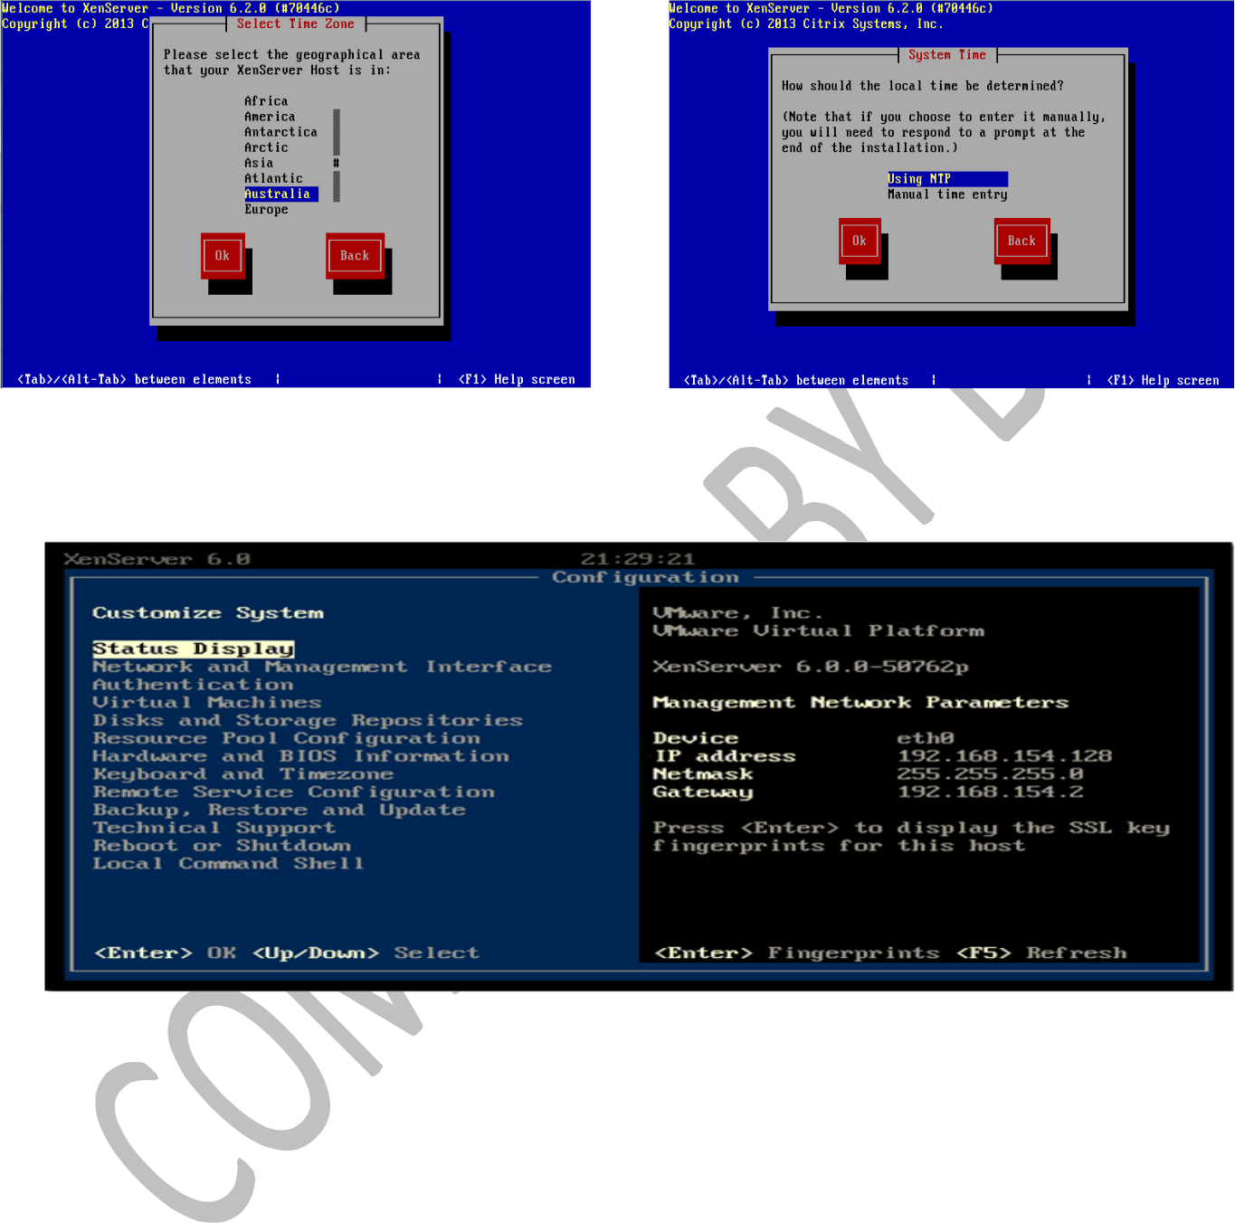

Once installation is done you will see the final screen shown below.

Xen Server Final Screenshot

**Step 2:Connect Xen Server to Xen Center**

Firstly, download the xen center a management utily from xen server by opening the xen severs IP address as a URL on browser. Once Xen center is downloaded, install it.Open Xen center from start menu of Windows.

|  |  |
| --- | --- |
| CLOUD COMPUTING LAB MANUAL COMPILED BY | PROF. BHUSHAN JADHAV CONTACT -:9702868662 |
|  |  |

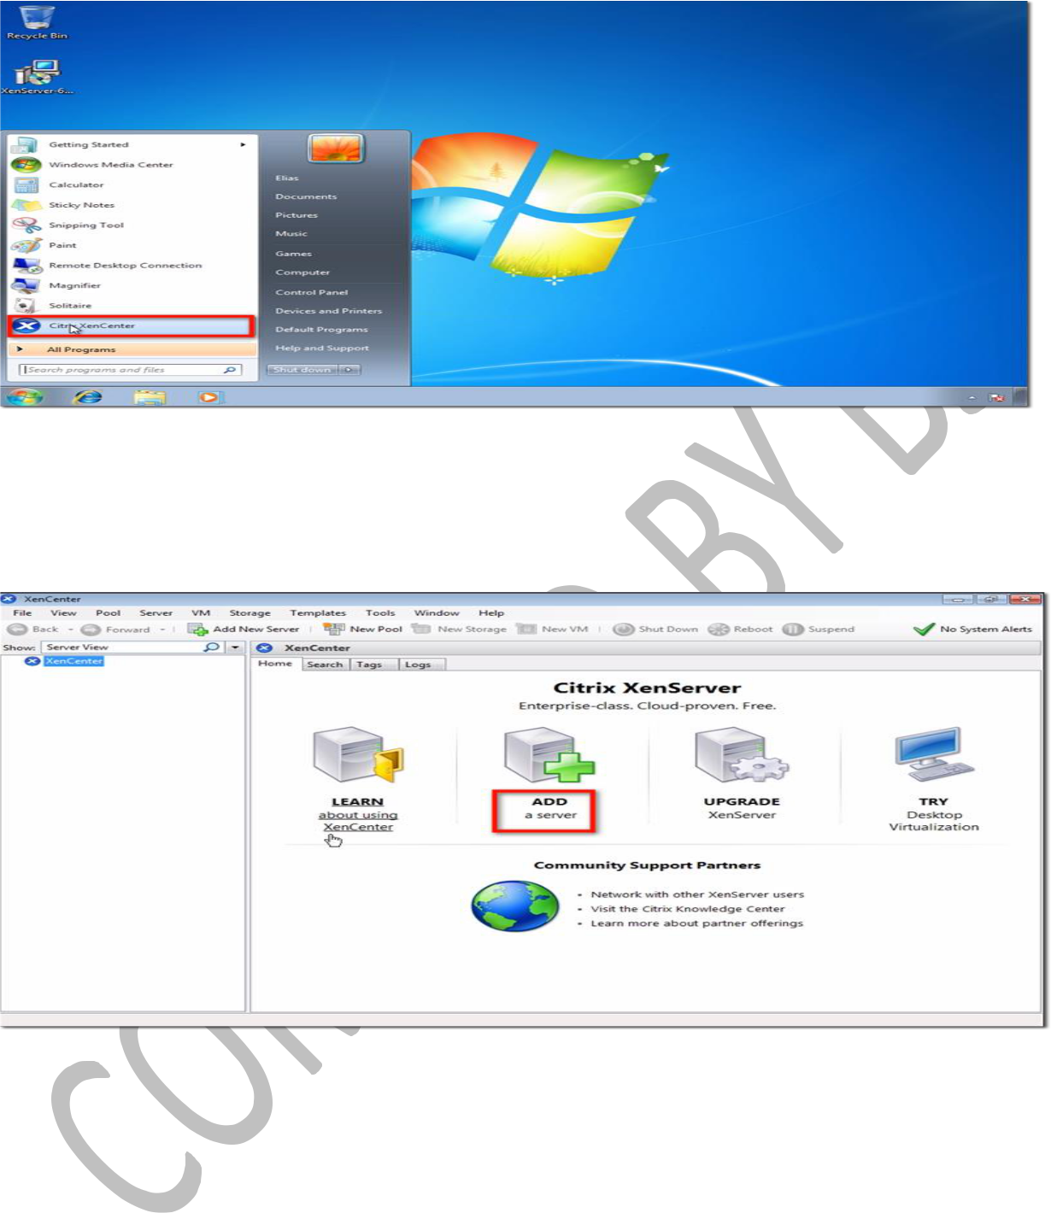

Here’s how XenCenter looks like (see screenshot below) before any hosts, resource pools, and so on, are added to it. To connect to the XenServer host you configured earlier, click Add a server.

Enter the IP address I asked you to take note of earlier. Also enter the password you assigned for your root account. Click Add.

|  |  |
| --- | --- |
| CLOUD COMPUTING LAB MANUAL COMPILED BY | PROF. BHUSHAN JADHAV CONTACT -:9702868662 |
|  |  |

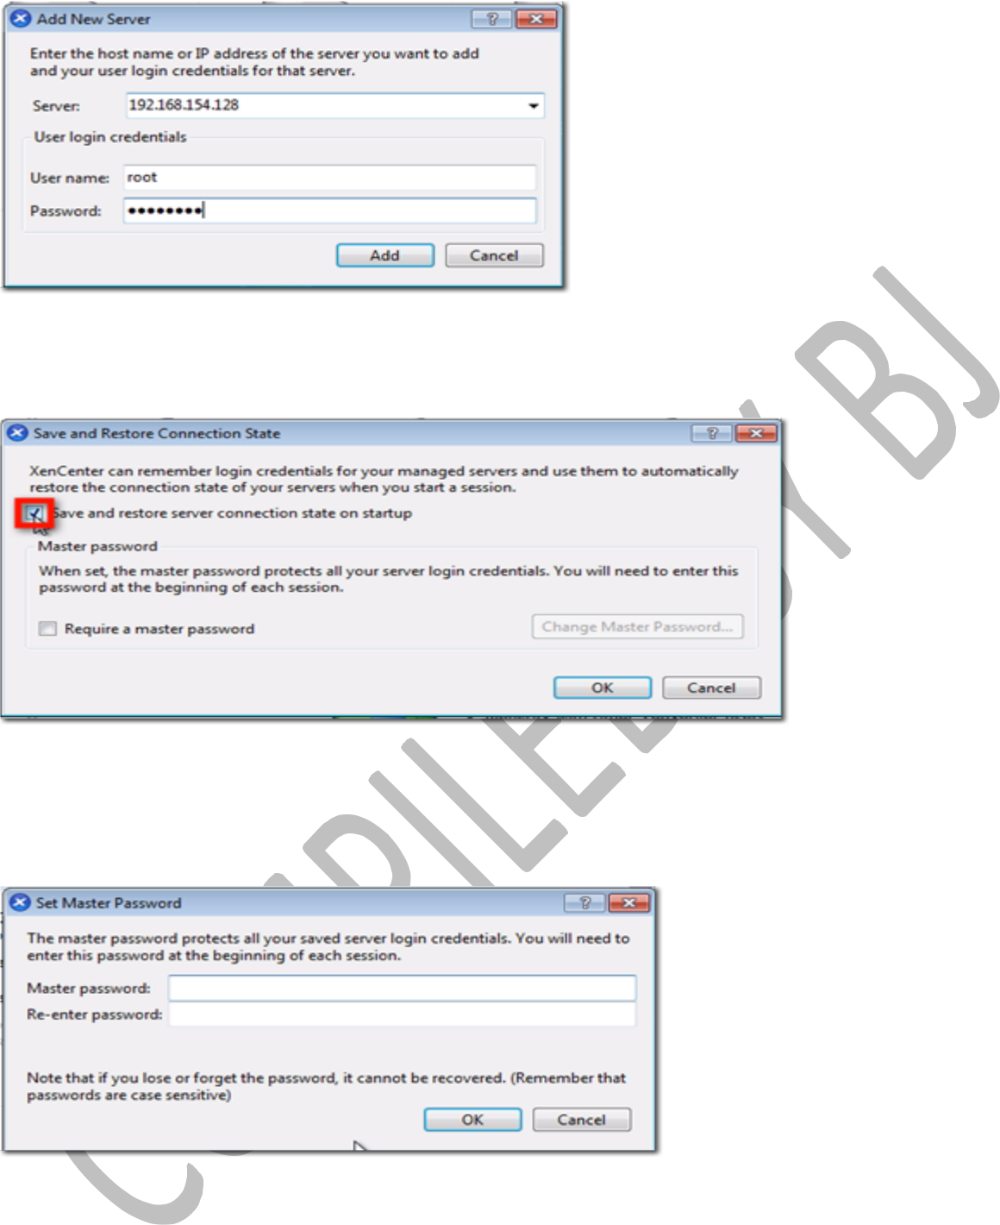

One of the first things you want to make sure as you’re adding a new XenServer to XenCenter is to save and restore the server connection state on startup. Check the box that will do just that.

Once you do that, you will be allowed to configure a master password for all the XenServers you’ll be associating with this XenCenter. Click the Require a master password checkbox if that’s what you want to do, and then enter your desired master password in the fields provided.

After you click OK, you’ll be brought back to the main screen, where you’ll see your XenServer already added to XenCenter.

|  |  |
| --- | --- |
| CLOUD COMPUTING LAB MANUAL COMPILED BY | PROF. BHUSHAN JADHAV CONTACT -:9702868662 |
|  |  |

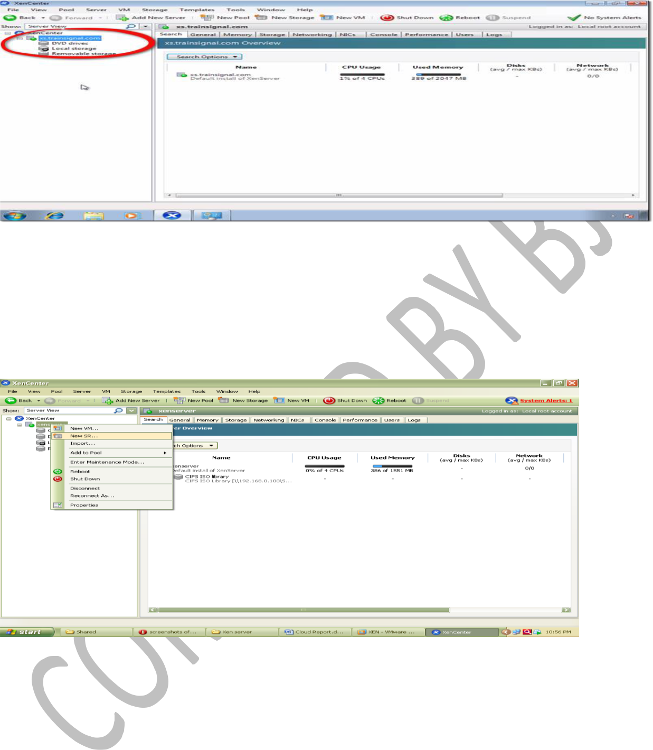

**Step-:3 Create Storage Repository and Installing VM**

Now Before Creating VM we have to Create Storage Repository first which is nothing but shared directory on Xen Center which holds all iso files and which is required to install Operating system on Xen Server its steps are as follows.Right click on Xenserver icon on xen center and click on New SR

Now Select Windows CIFS library

|  |  |
| --- | --- |
| CLOUD COMPUTING LAB MANUAL COMPILED BY | PROF. BHUSHAN JADHAV CONTACT -:9702868662 |
|  |  |

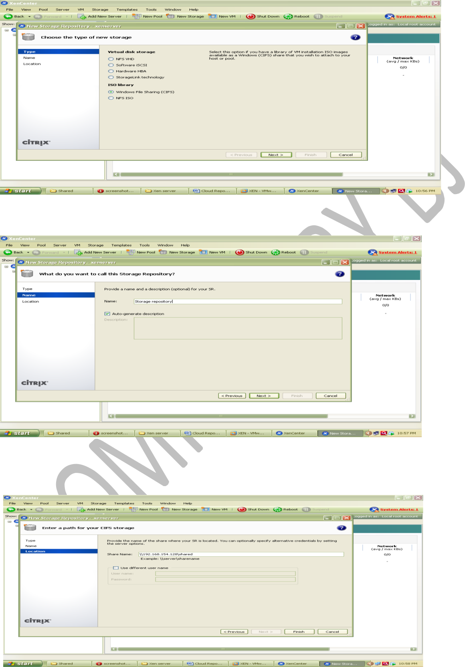

Specify Storage Repository Name

Now specify path of shared folder at client side which holds all iso files of os or VM which we are going to install on Xen Server.

.

|  |  |
| --- | --- |
| CLOUD COMPUTING LAB MANUAL COMPILED BY | PROF. BHUSHAN JADHAV CONTACT -:9702868662 |
|  |  |

At the end Click on finish to create SR.

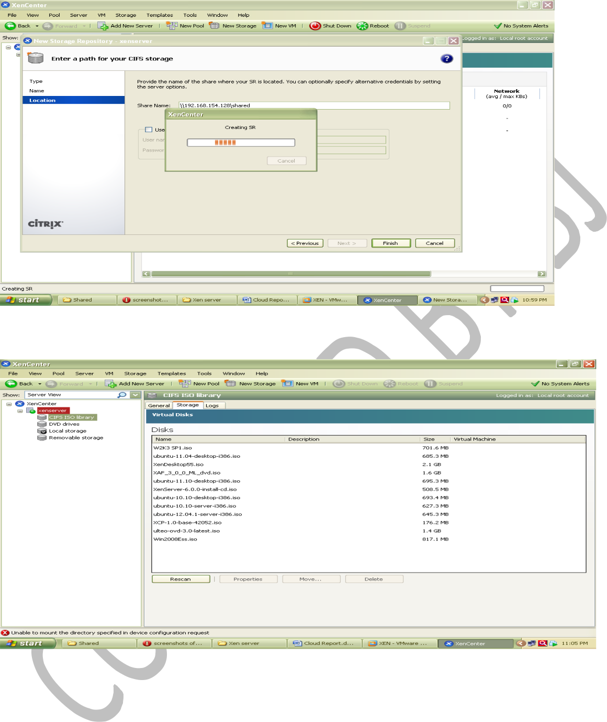

To check all iso files click on CIFS library and select storage this will show you all iso files.

Installation of UBUNTU Server on Xen Server

Step 1 -: Right click on Xenserver icon on xen center and select New VM

|  |  |
| --- | --- |
| CLOUD COMPUTING LAB MANUAL COMPILED BY | PROF. BHUSHAN JADHAV CONTACT -:9702868662 |
|  |  |

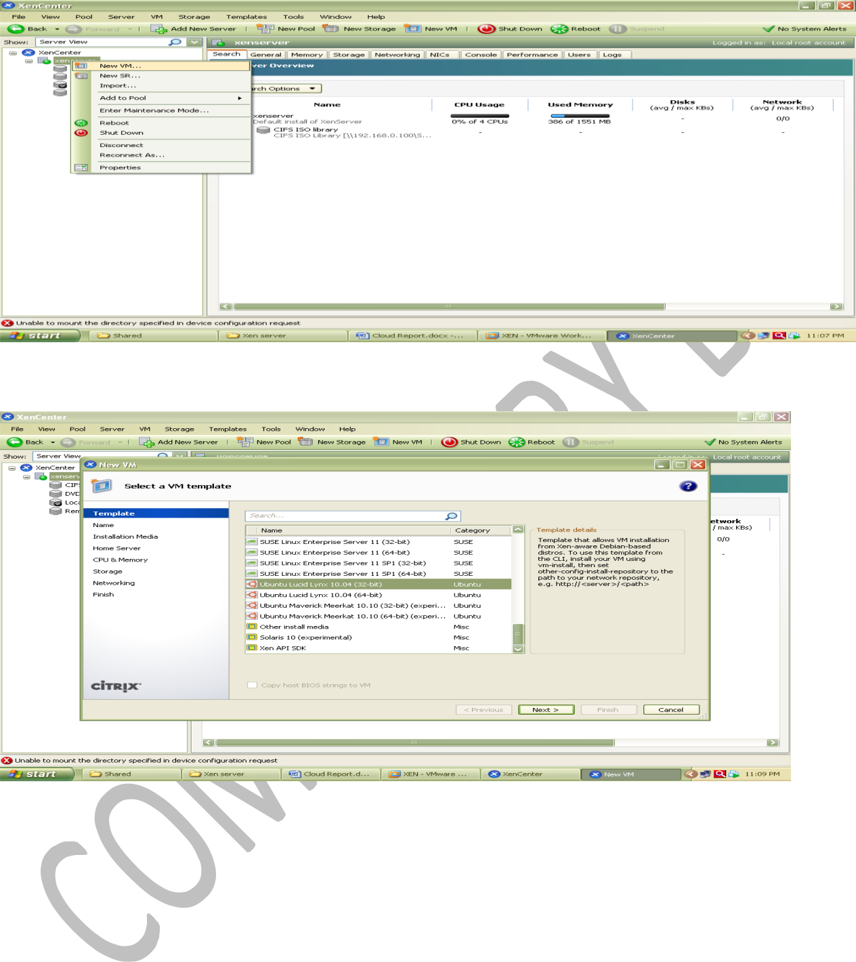

Now select an Operating System to be install here select Ubuntu Lucid Lynx and click on next

Now specify Instance Name as ubuntu server

|  |  |
| --- | --- |
| CLOUD COMPUTING LAB MANUAL COMPILED BY | PROF. BHUSHAN JADHAV CONTACT -:9702868662 |
|  |  |

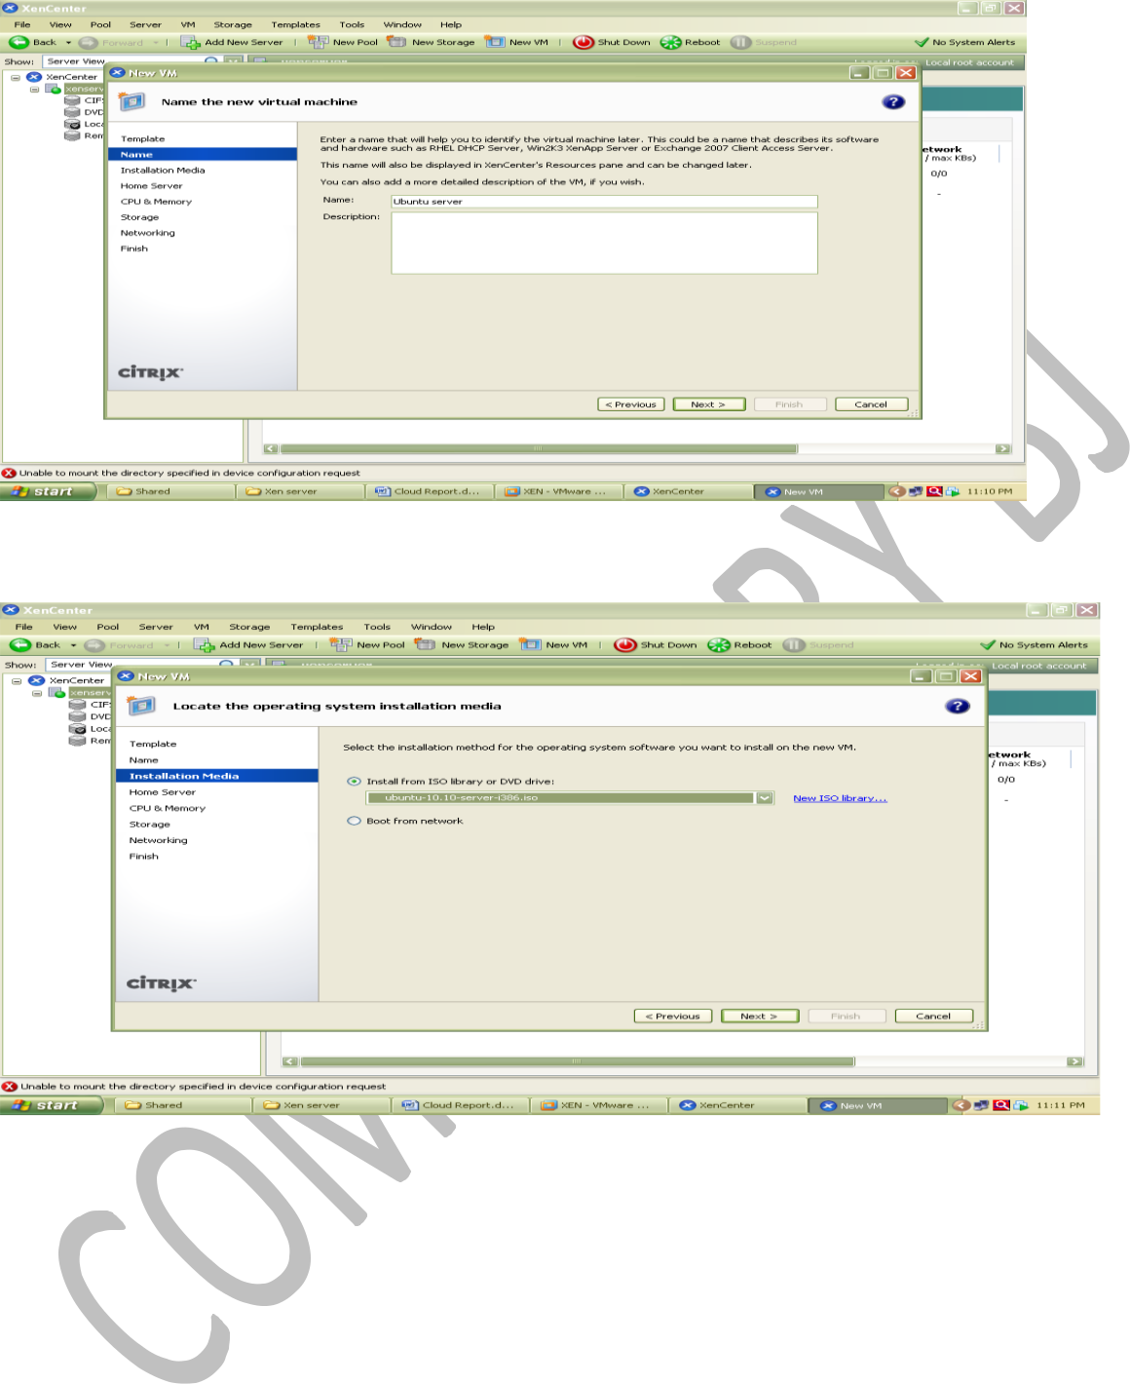

Select iso file of Ubuntu server 10.10 to be install

Now select hardware for vm i.e. no. of cpu’s and memory

|  |  |
| --- | --- |
| CLOUD COMPUTING LAB MANUAL COMPILED BY | PROF. BHUSHAN JADHAV CONTACT -:9702868662 |
|  |  |

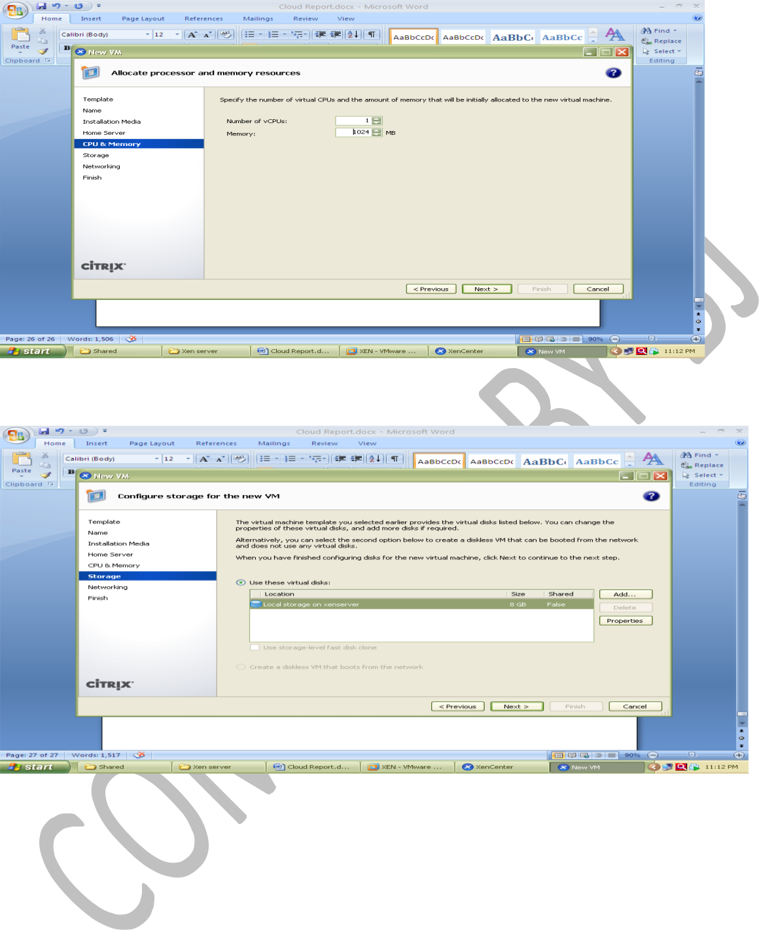

Select local storage

Select network

|  |  |
| --- | --- |
| CLOUD COMPUTING LAB MANUAL COMPILED BY | PROF. BHUSHAN JADHAV CONTACT -:9702868662 |
|  |  |

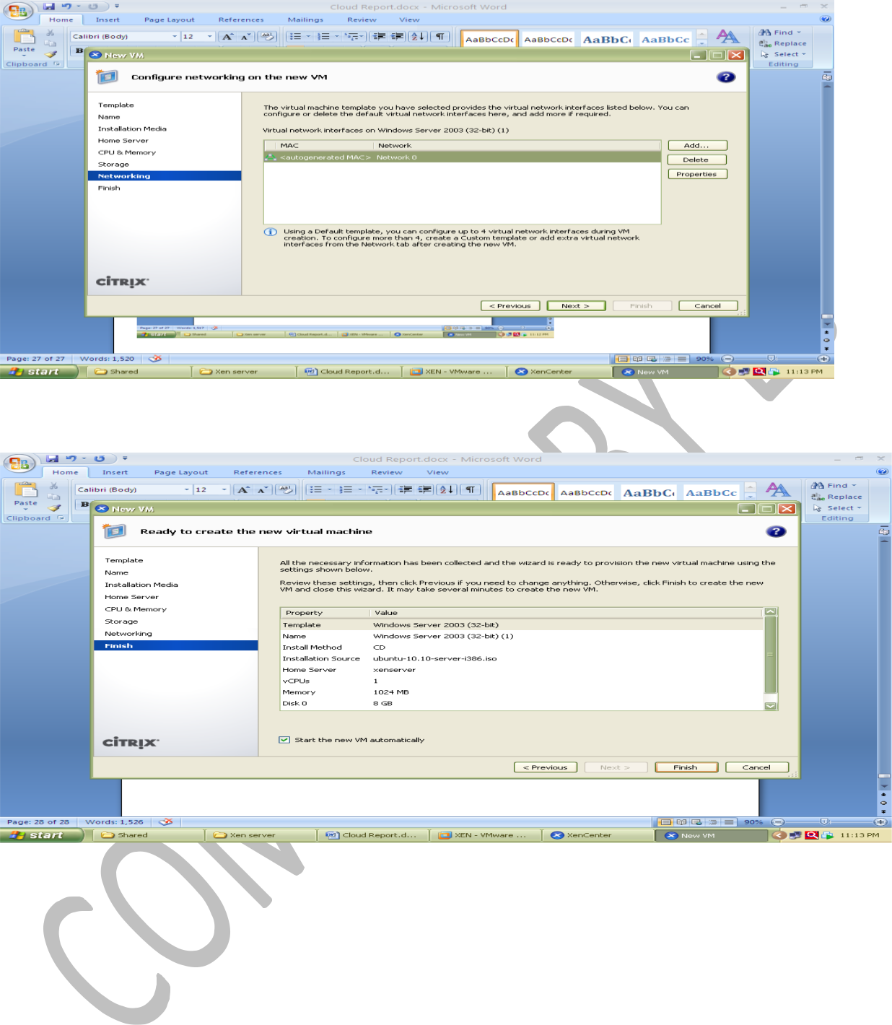

And click on finish

Now go to Console tab to install ubuntu and follow installation Steps.

|  |  |
| --- | --- |
| CLOUD COMPUTING LAB MANUAL COMPILED BY | PROF. BHUSHAN JADHAV CONTACT -:9702868662 |
|  |  |

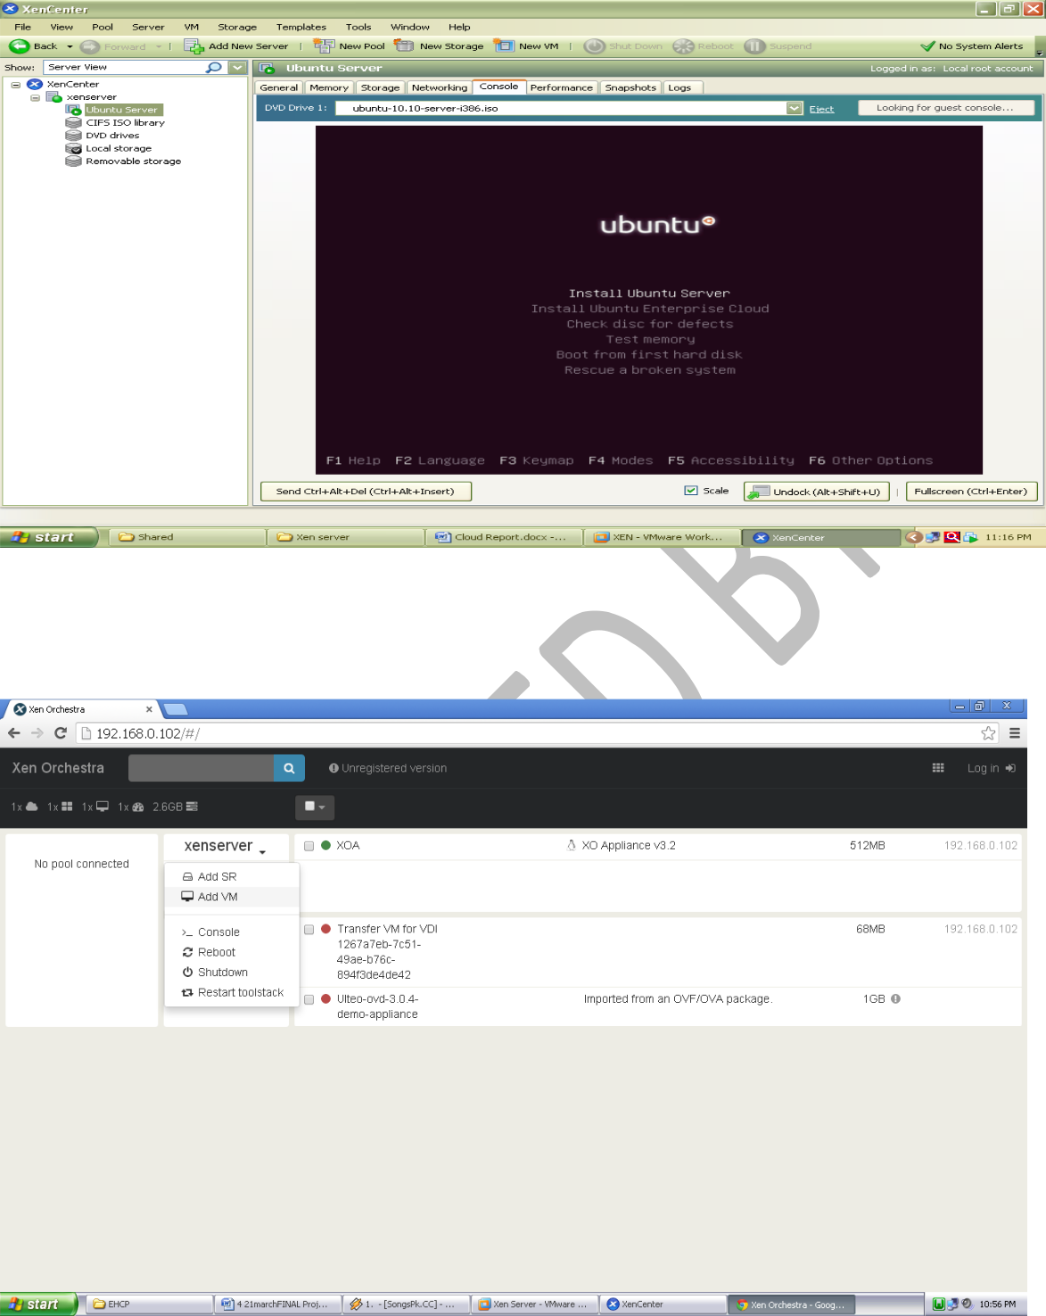

The Xen orchestra provides web based functionality of Xen Center.it provides access to all the VMs with their lifecycle management which are installed over Xen Server shown in figure 5.28

Xen Orchestra (XOA) Portal

The Windows XP image running on Xen Orchestra over Google chrome web browser is shown in following screenshot

|  |  |
| --- | --- |
| CLOUD COMPUTING LAB MANUAL COMPILED BY | PROF. BHUSHAN JADHAV CONTACT -:9702868662 |
|  |  |

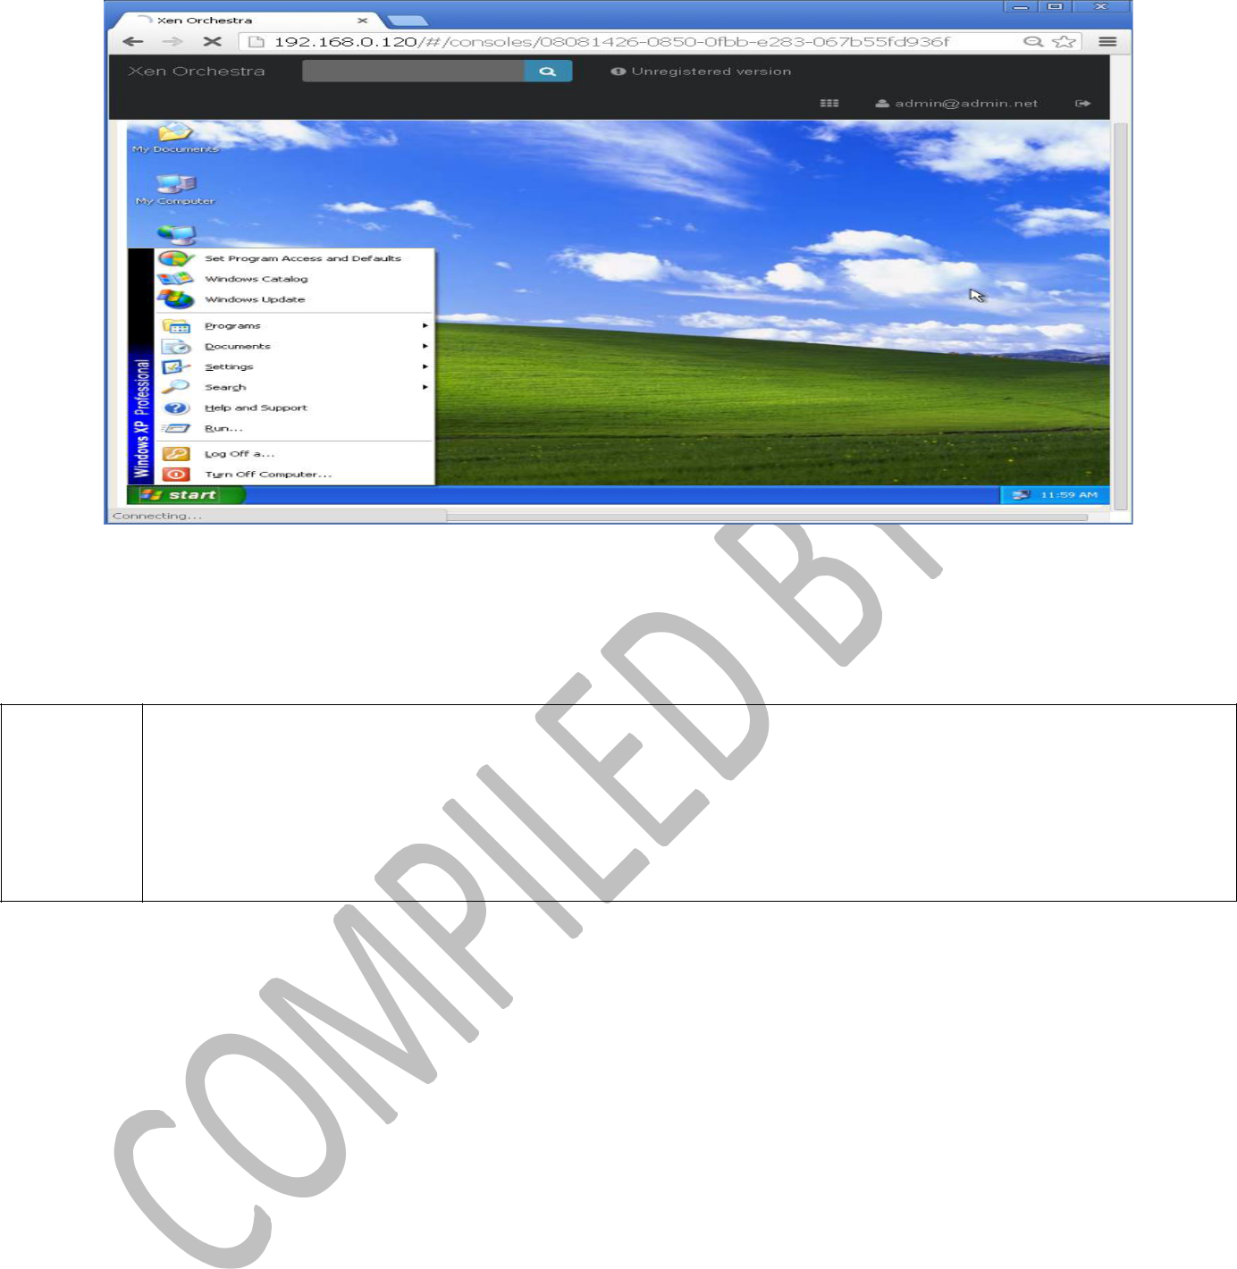

Windows XP running on Xen orchestra (XOA)

**LAB 3**

**Installation and Configuration of Ulteo to demonstrate on demand Application delivery over web browser to explore SaaS Environment.**

Ulteo is an open source Virtual Desktop infrastructure project that can deliver various operating systems deskops - including Windows and Linux desktops or applications - to end usersThe Open Virtual Desktop allows corporates to deploy virtualized GNU/Linux and/or Windows desktops. Parts of Ulteo products are based on Debian and Ubuntu. Ulteo Open Virtual Desktop is an open source alternative to Citrix and VMWare solutions.

The steps for installation and configuration of Ulteo are given as follows

Step 1: Install Ulteo through DVD or Open Ulteo OVF file in Vmware player by selecting import VM button

1. If you haven't an Ulteo OVD DVD-ROM yet, please download the corresponding ISO file from this place at www.ulteo.com and burn it to a fresh DVD.

|  |  |
| --- | --- |
| CLOUD COMPUTING LAB MANUAL COMPILED BY | PROF. BHUSHAN JADHAV CONTACT -:9702868662 |
|  |  |